**PROJECT TITLE:** MEDICAL INVENTORY MANAGEMENT

**College Name:** KPR College of Arts Science and Research

**College Code**:

**TEAM ID:**

**TEAM MEMBERS:**

Team Leader: Nithyasree KS

Email: [23bit037@kprcas.ac.in](mailto:23bit037@kprcas.ac.in)

Team Member1: Nivetha S

Email: [23bit038@kprcas.ac.in](mailto:23bit038@kprcas.ac.in)

Team Member2: Kayathri G

Email: [23bit025@kprcas.ac.in](mailto:23bit025@kprcas.ac.in)

Team Member3: Abinesh P

Email: [23bit01@kprcas.ac.in](mailto:23bit01@kprcas.ac.in)

**1. INTRODUCTION**

1.1 Project Overview:

**Medical inventory management** refers to the systematic process of overseeing the ordering, storage, tracking, and use of medical supplies, equipment, and pharmaceuticals within healthcare facilities such as hospitals, clinics, pharmacies, and laboratories.

1.2 Purpose:

The main purpose of medical inventory management is to ensure the continuous availability of essential medical supplies and equipment. It helps prevent shortages, overstocking, and wastage due to expiration. By maintaining accurate records, it supports regulatory compliance and safety standards. Efficient inventory management also reduces operational costs and improves overall healthcare service quality. Ultimately, it ensures timely and effective patient care.

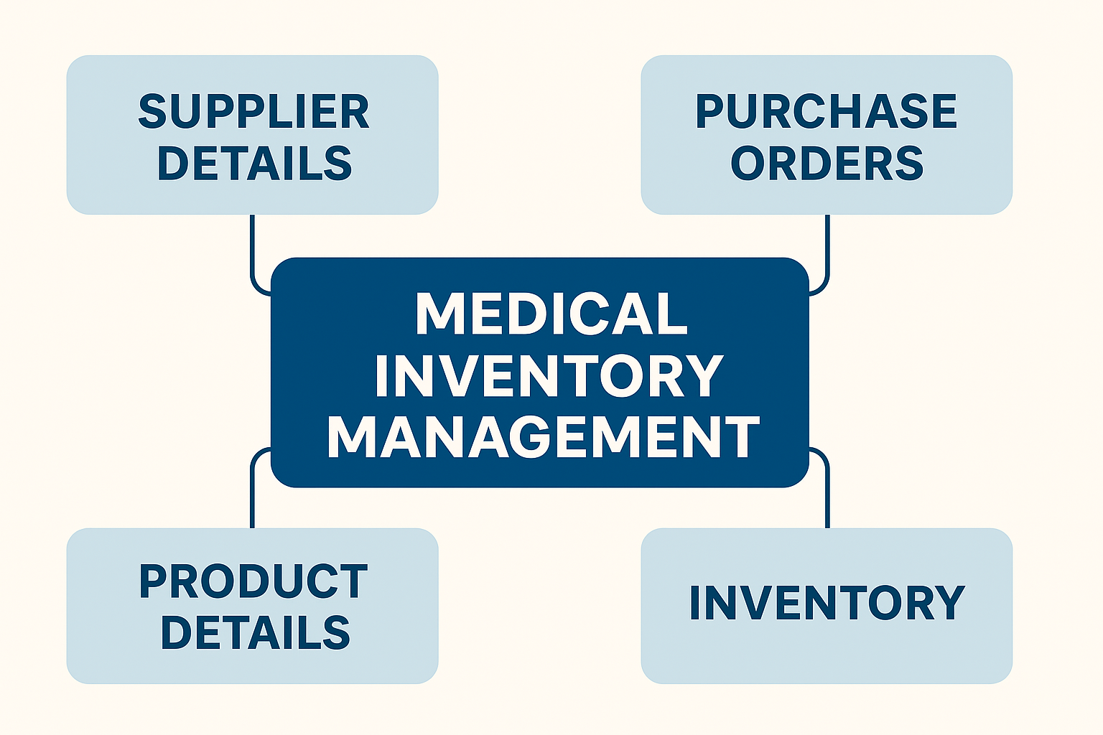

Fig: Medical inventory management

**2.DEVELOPMENT PHASE**

2.1 Creating Developer Account:

* By using this URL -<https://developer.salesforce.com/signup>

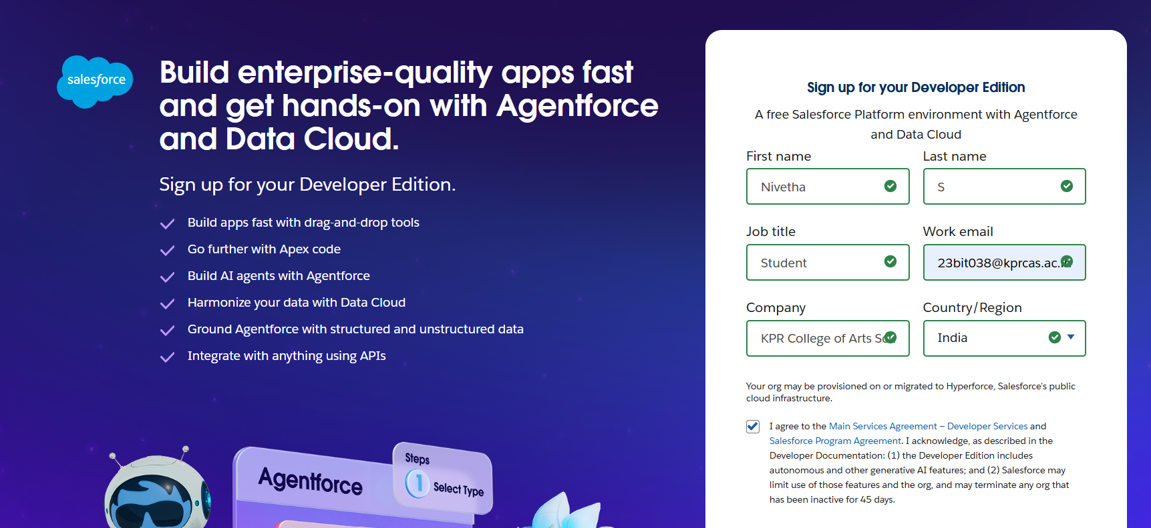

2.2 Created Custom Object:

Product:

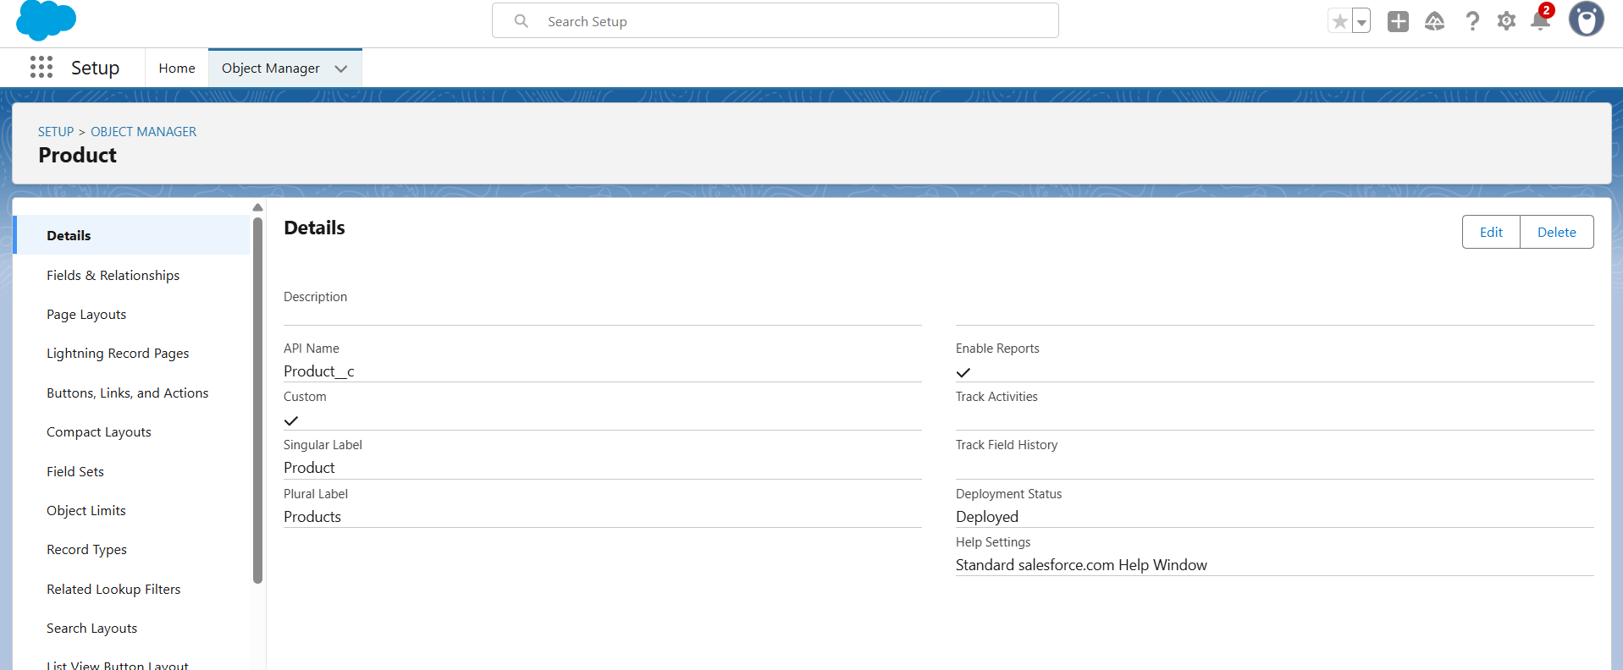

Purchase Order :

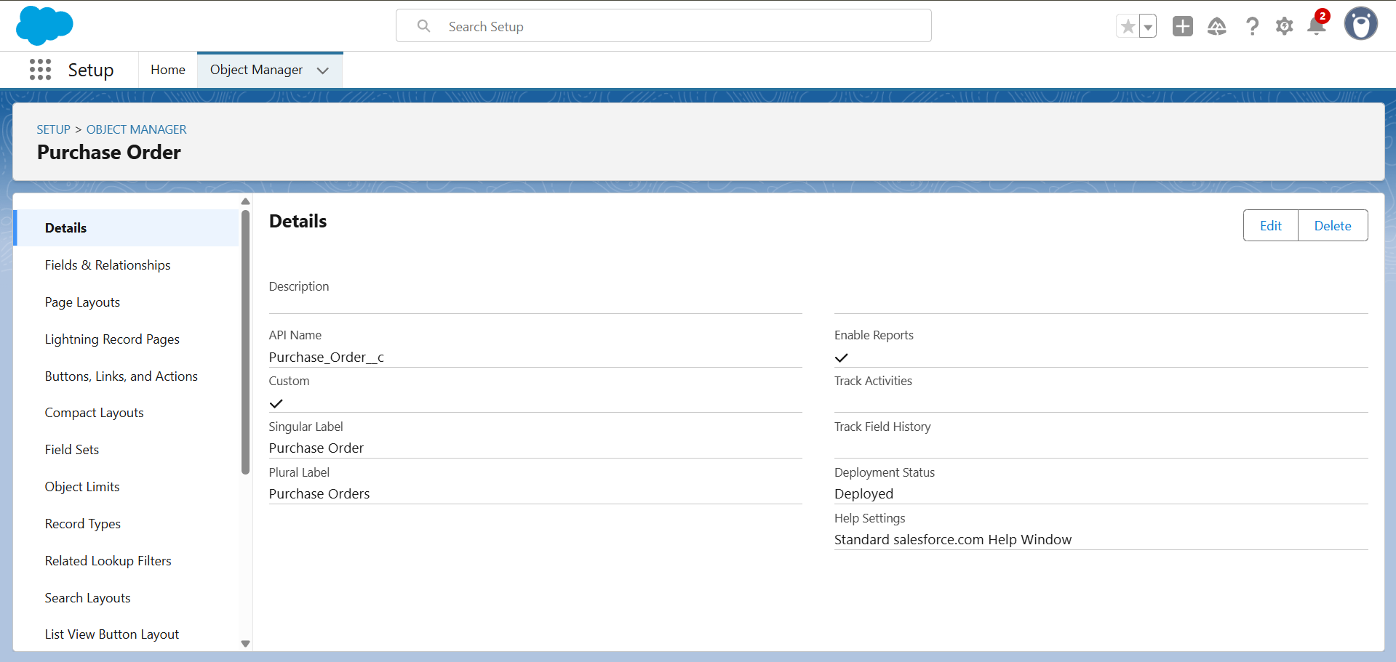

Order Item :

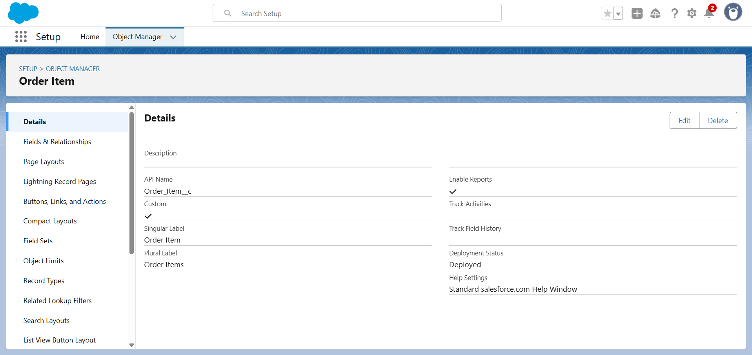

Inventory Transaction :

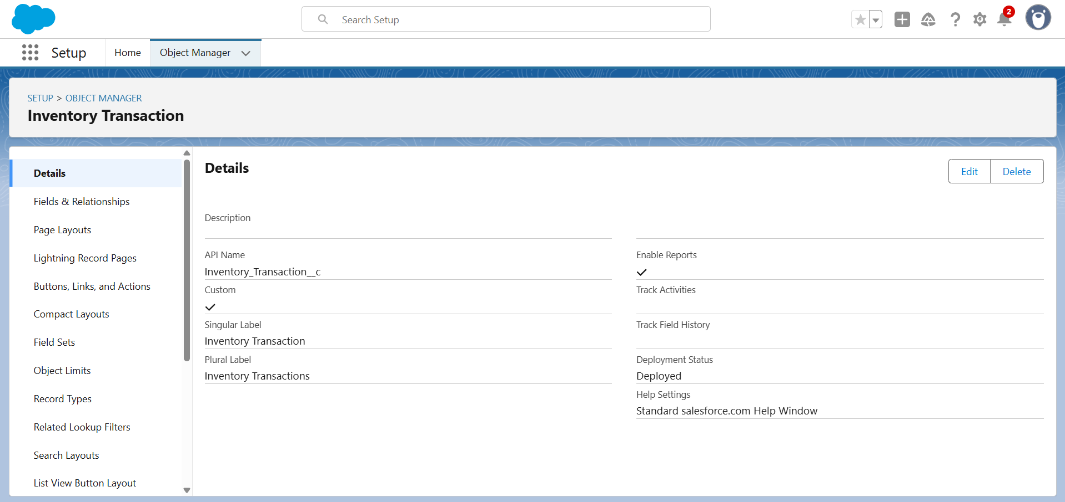

Supplier :

2.3 Created Tabs for custom objects.

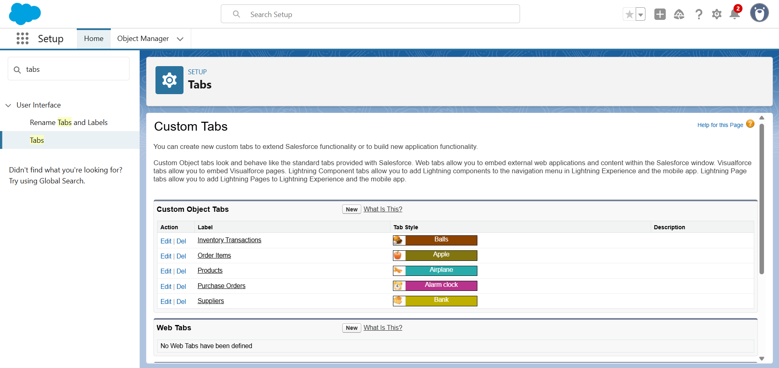

2.4 Developed Lightning App with relevant tabs.

2.5 Configured fields and relationships.

Product :

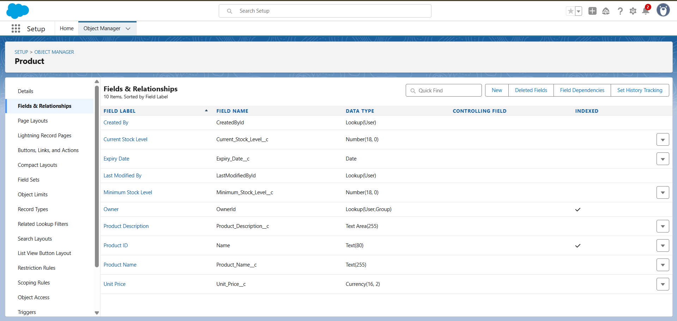

Purchase Order :

Order Item :

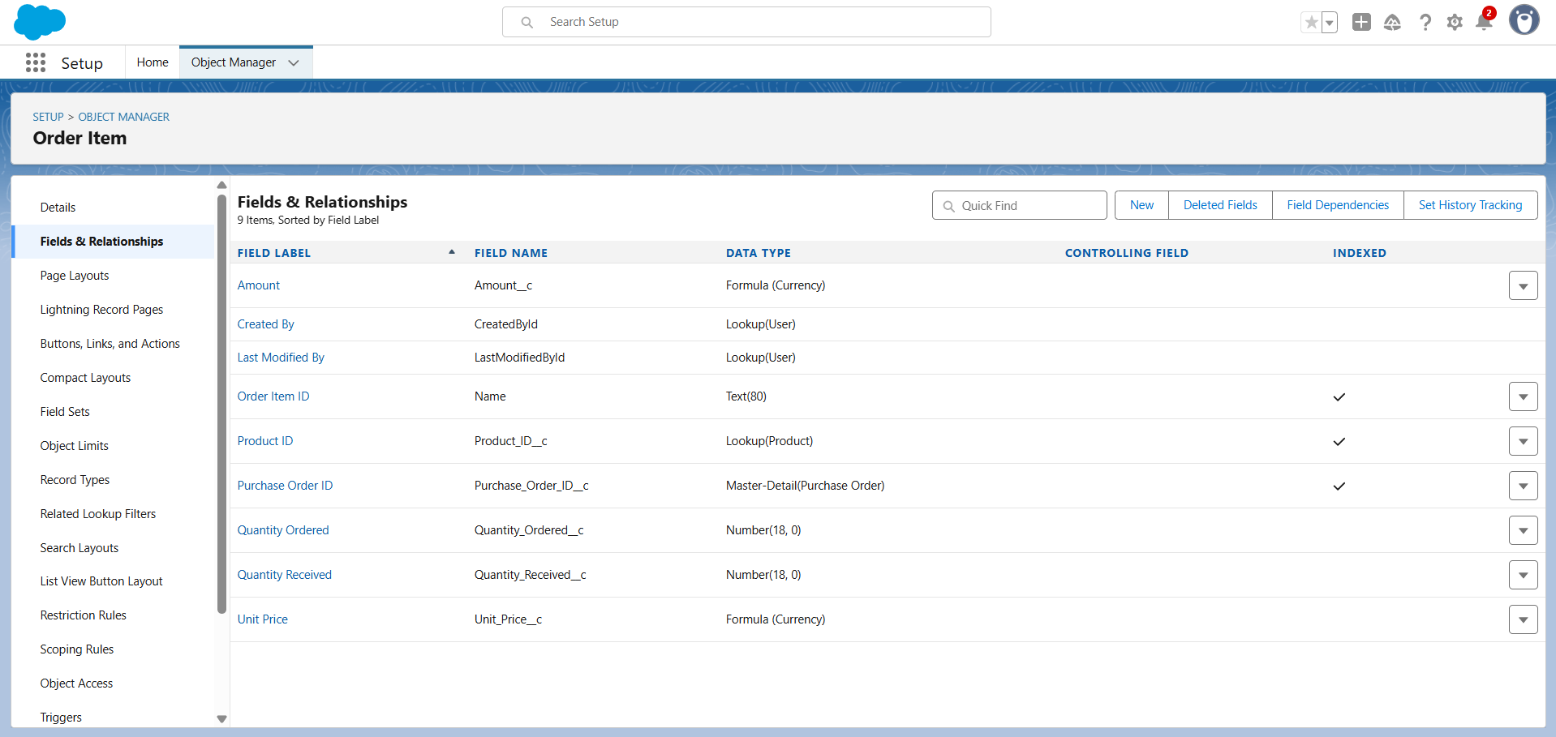

Inventory Transaction:

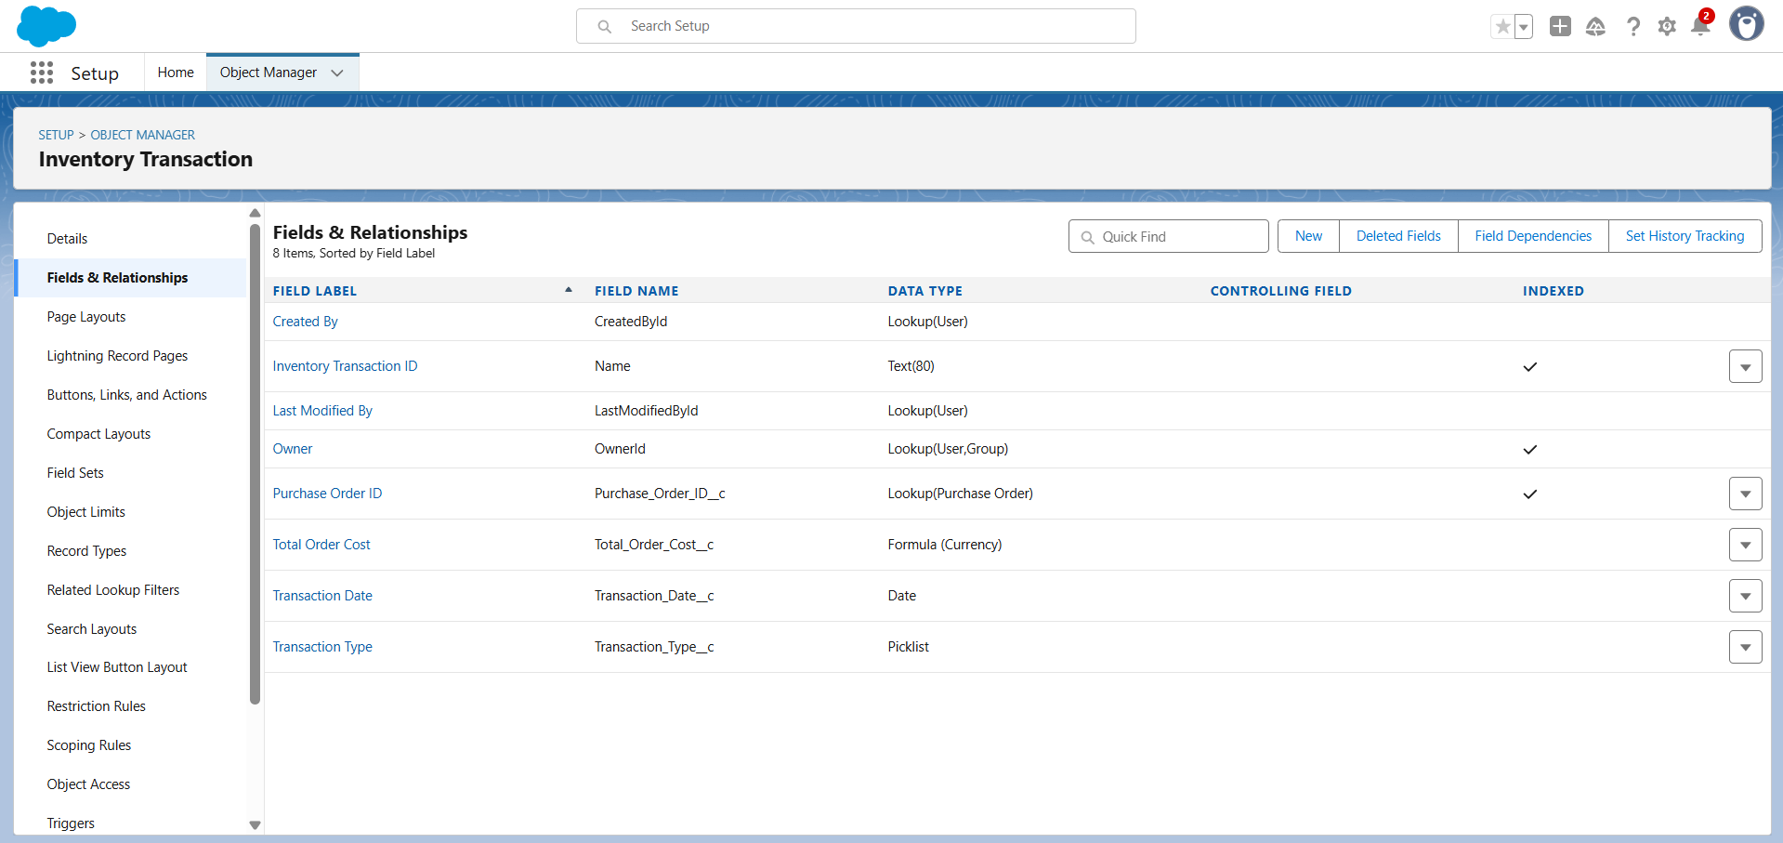

Supplier:

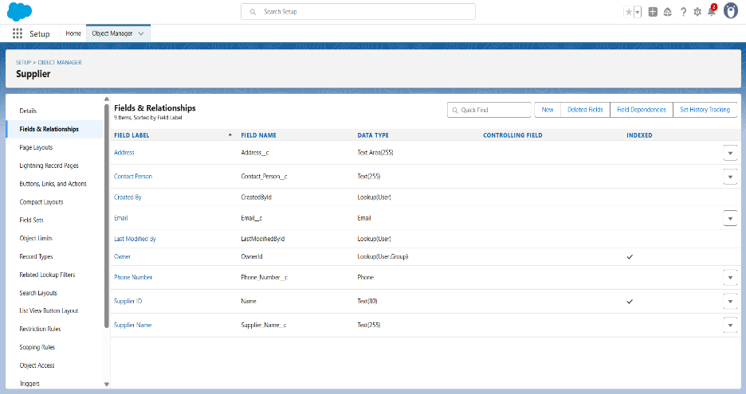

* 1. Customizing Page Layout.

Product Layout:

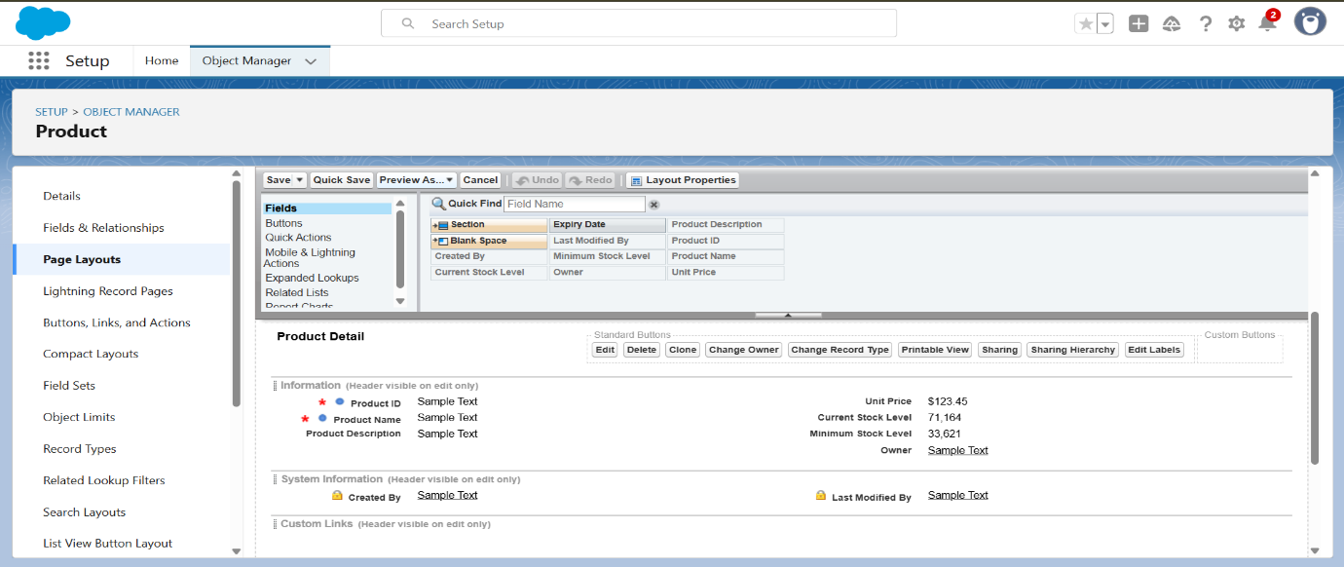

Purchase Order Layout:

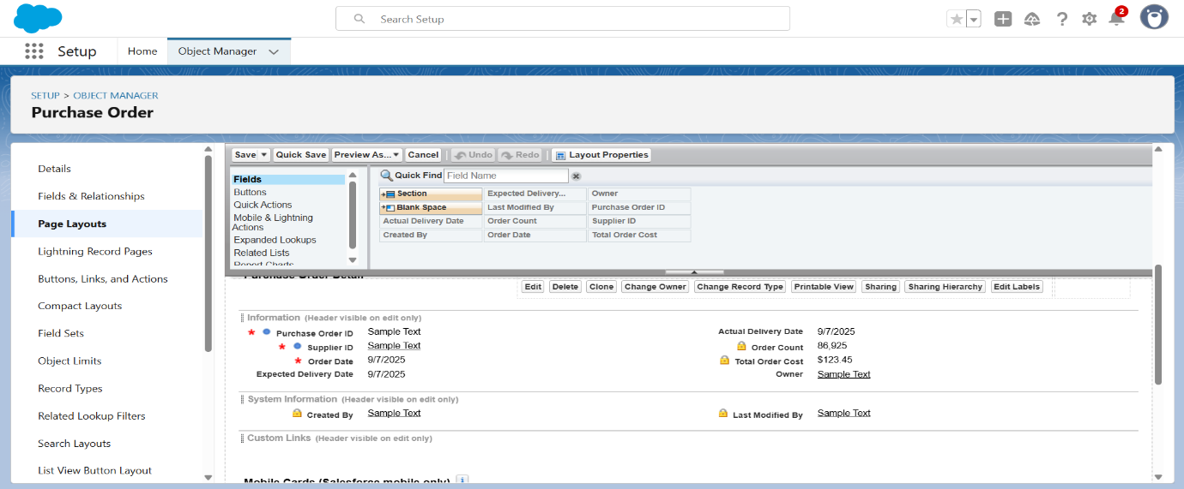

Order Item Layout:

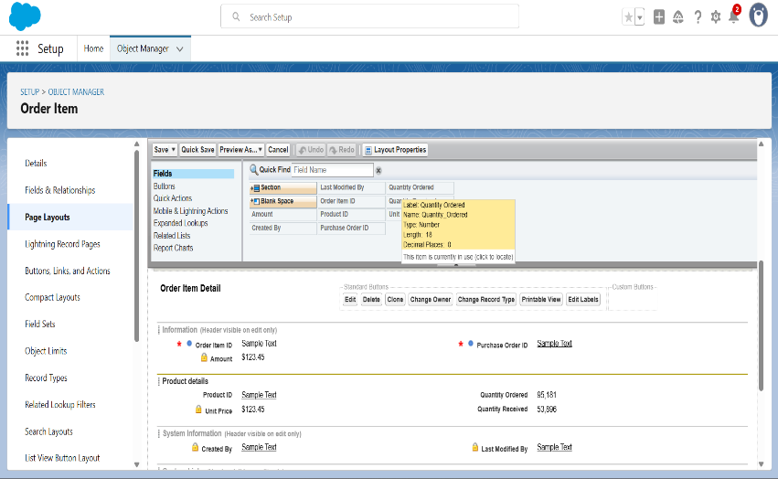

Inventory Transaction Layout:

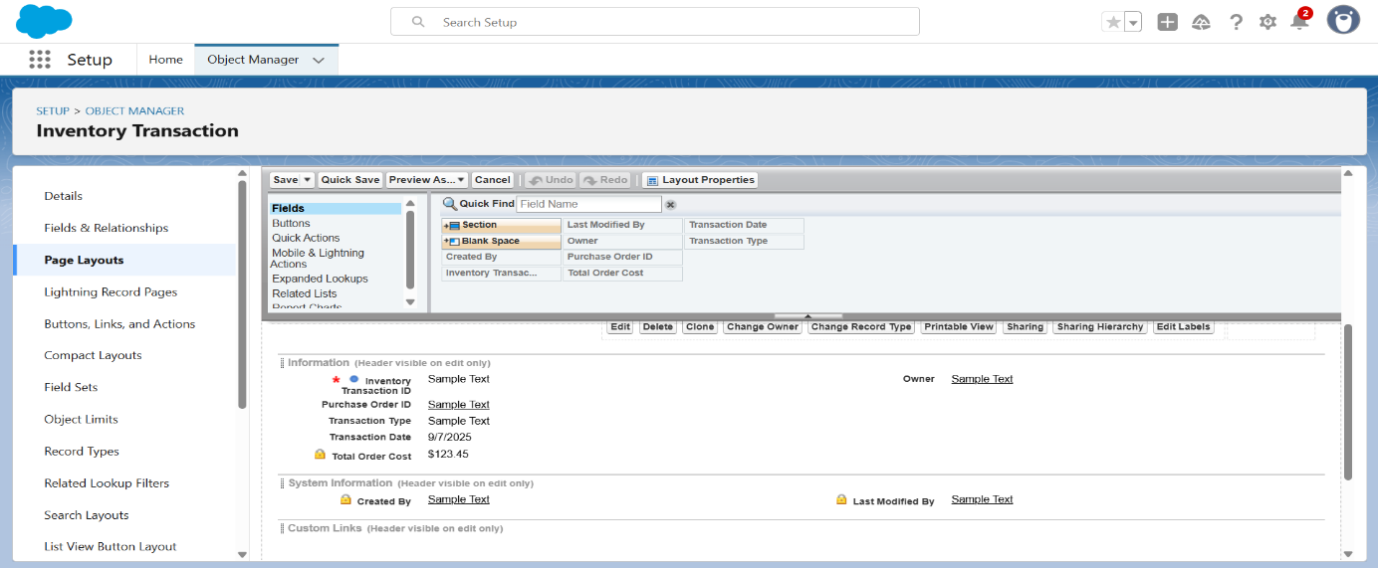

Supplier Layout:

2.7 Created Compact Layout.

Product Layout:

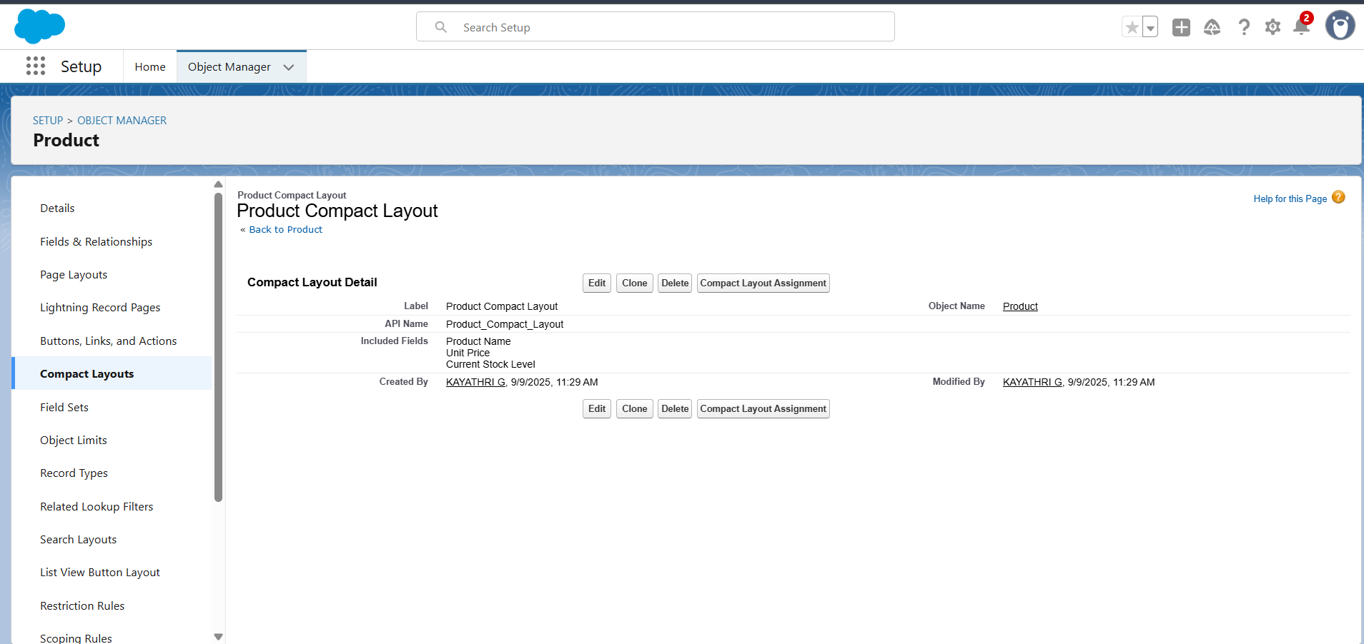

Purchase Order Compact Layout:

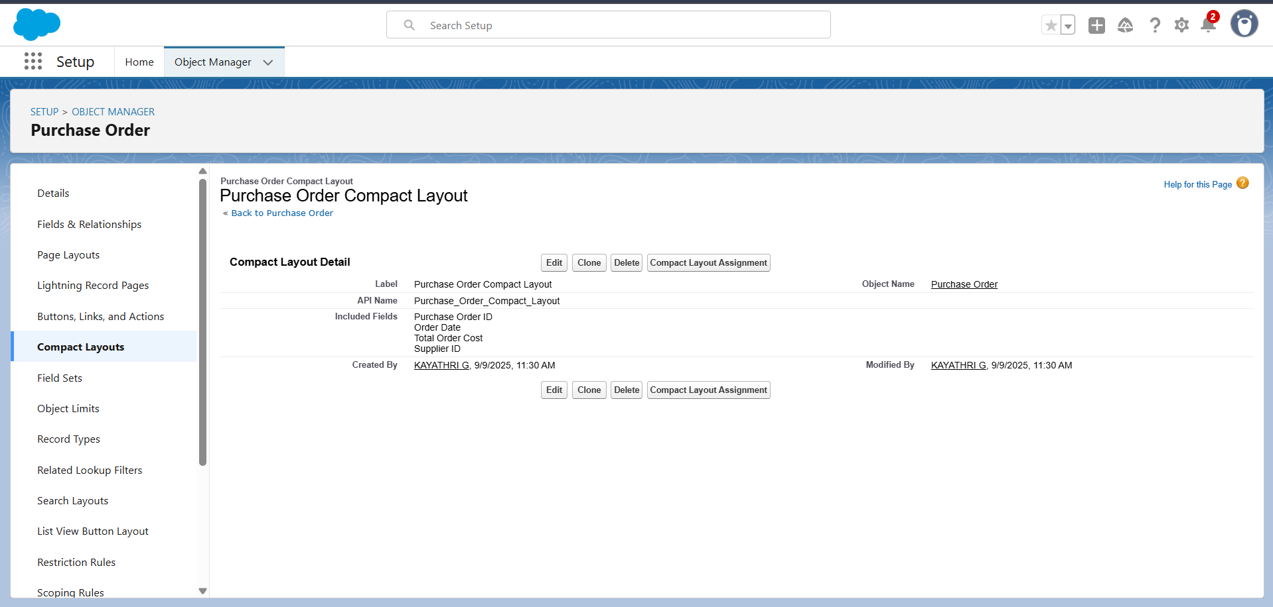

2.8 Created a Validation Rule.

Purchase Order Validation Rule:

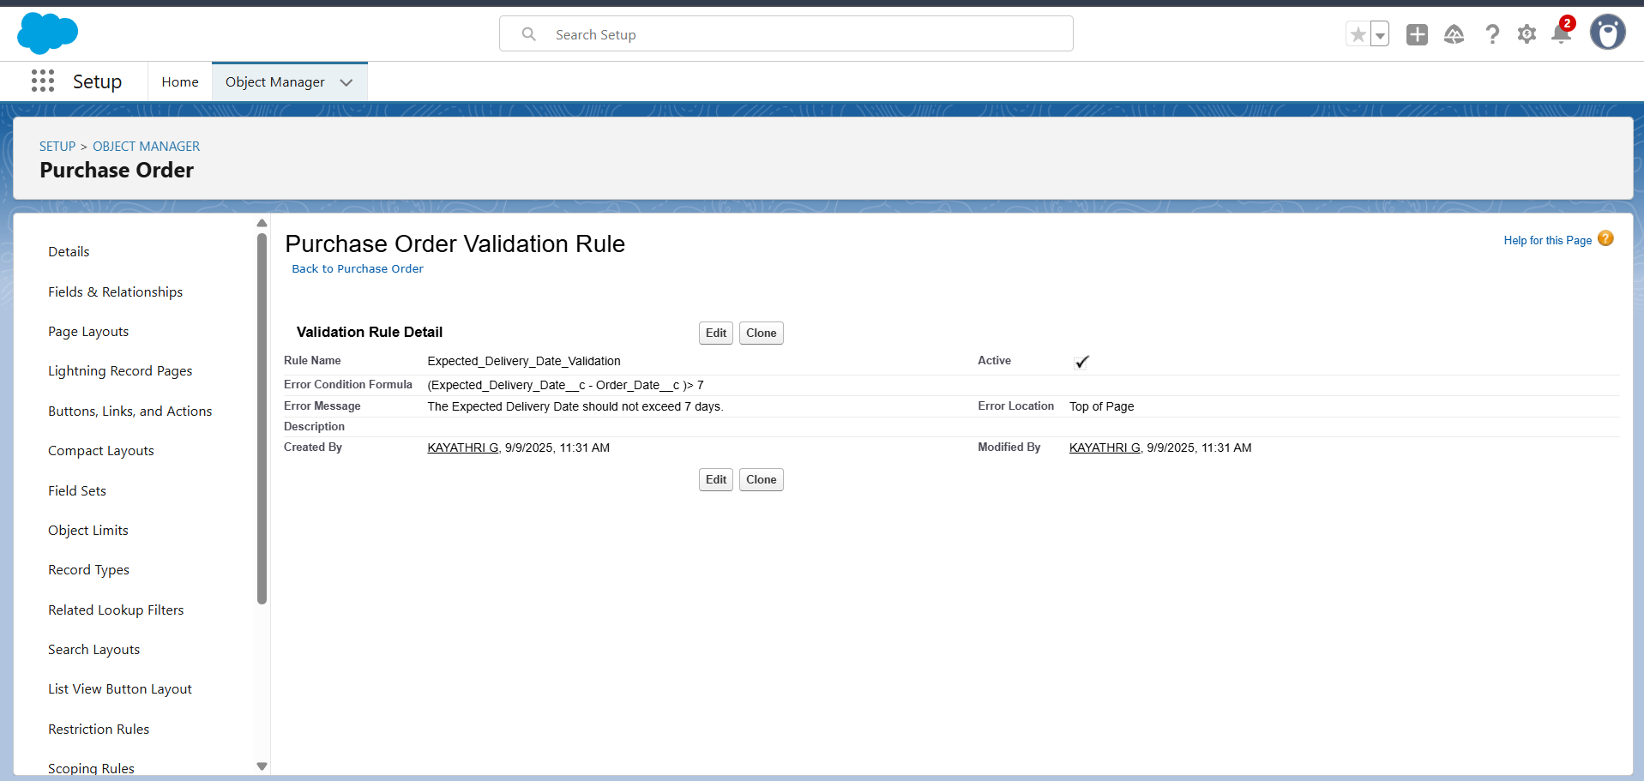

2.9 Created Profiles.

Inventory Manager:

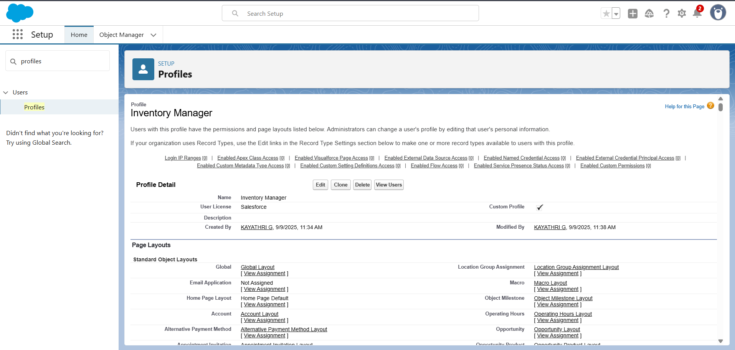

Purchase Manager:

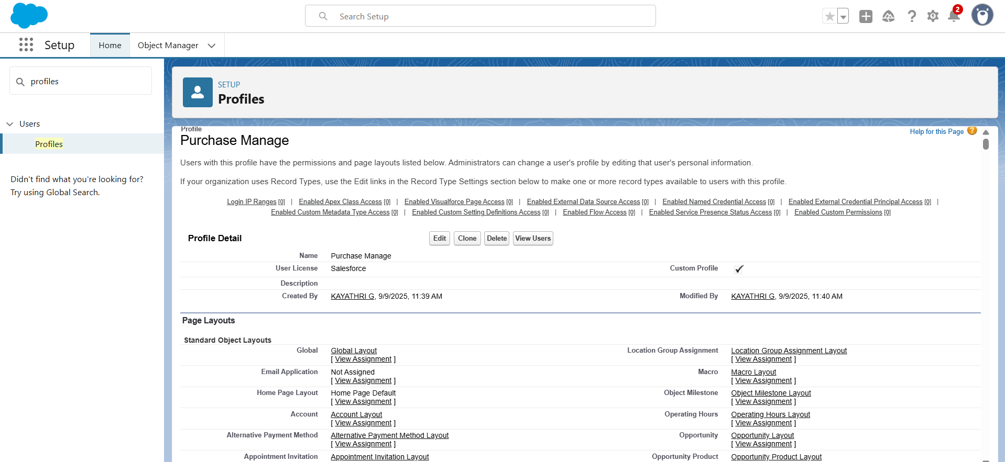

2.10 Created Roles.

2.11 Created a Permission Set.

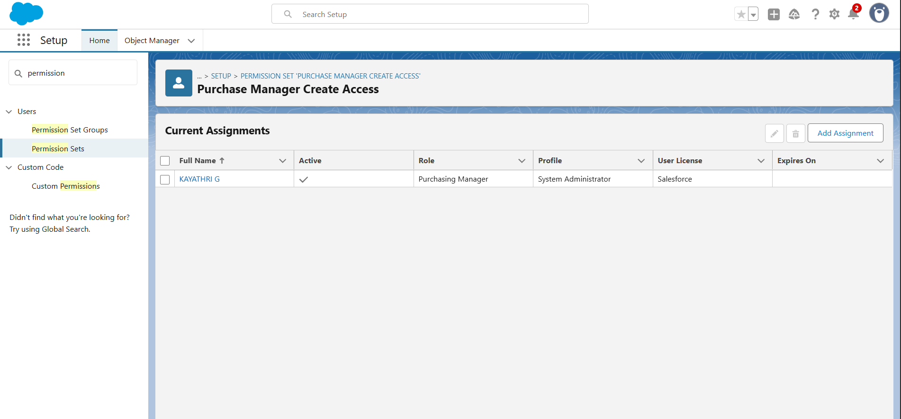

2.12 Created a Flow.

2.13 Created Apex Trigger.

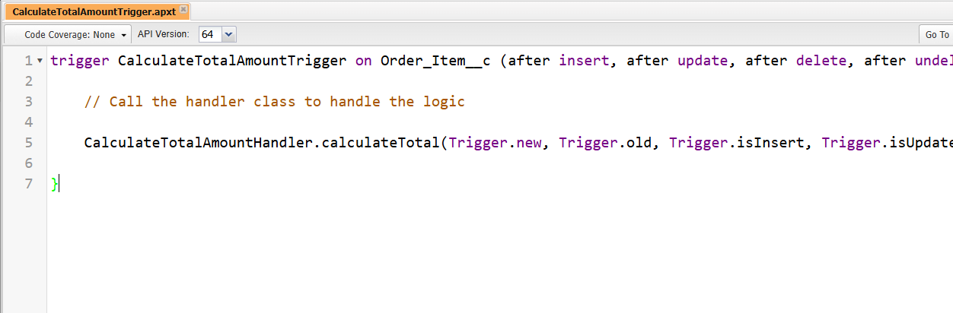

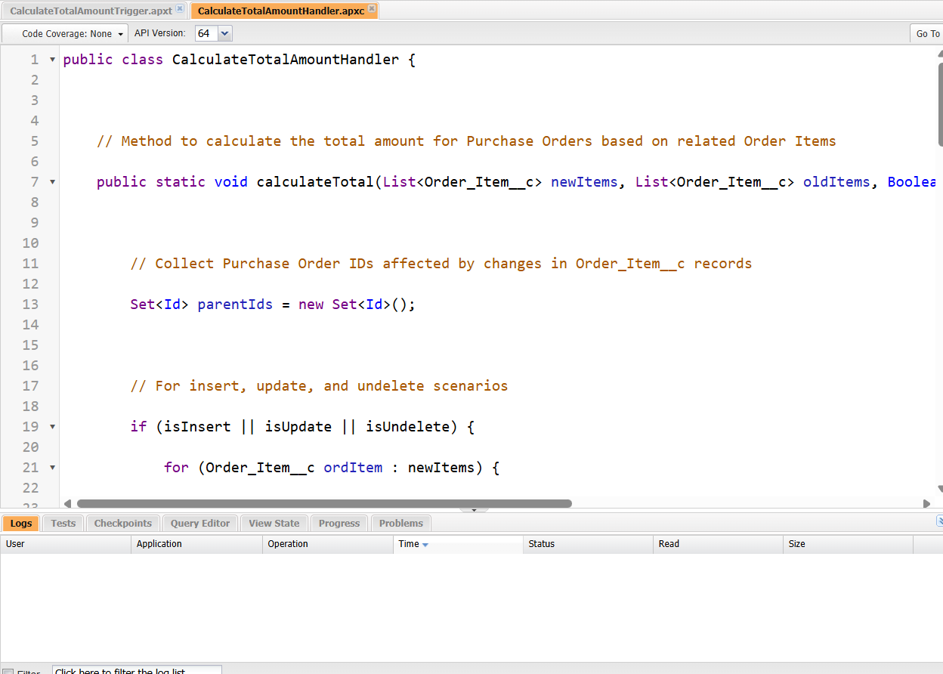

2.14 Created Reports.

Purchase Orders based on Suppliers:

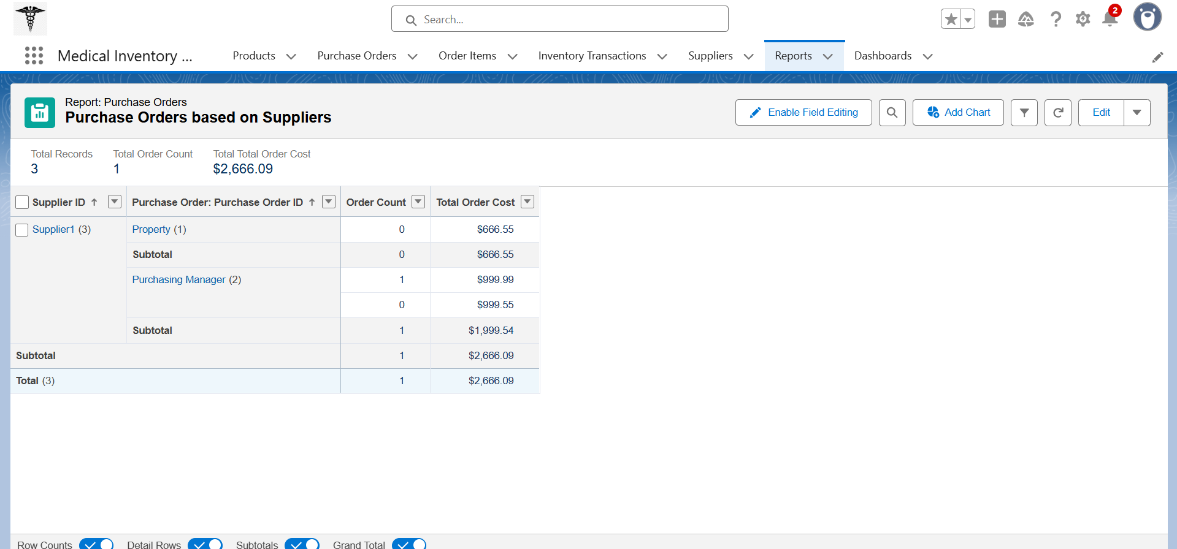

Complete Purchase Details Report:

